HEAVY RAINFALL IN MALAWI
The month of February has been painful to bear to some people living in some parts of Malawi. February is regarded as a difficult month already as it is the time that many people experience challenges in terms of finances. Coming from the celebrations of Christmas and New Year, people struggle to be feeding their families with many bills at their disposal. It is already farming season, hence farm inputs have to be purchased. In addition, schools are also opening and there’s need to take care for the school fees of the children. The demands of living become too much to bear with as the salaries of many citizens appear to be low.

Unfortunately, when we started this year, we were confronted with cholera outbreak which has claimed many lives already and still does. Just shortly after, heavy rains caused damage in most parts of Malawi. Some areas have experienced hailstorms and floods which have damaged some houses and crops. For example, in Kasungu (in the Central Region) some tobacco and maize fields have been destroyed. Two people died in Mzimba, the Northern Region of Malawi, when they were washed away by running water around Enukweni river. Some houses got submerged in Machinjiri – Blantyre, the Southern Region of Malawi, and ended sweeping away part of Machinjiri road making it impassable to reach the township of Limbe.

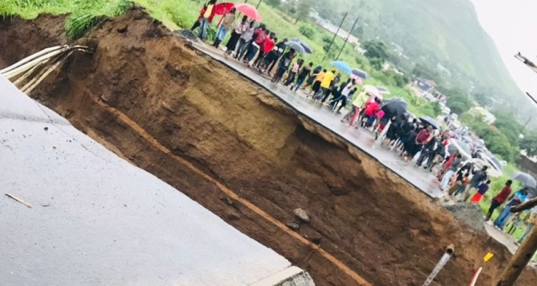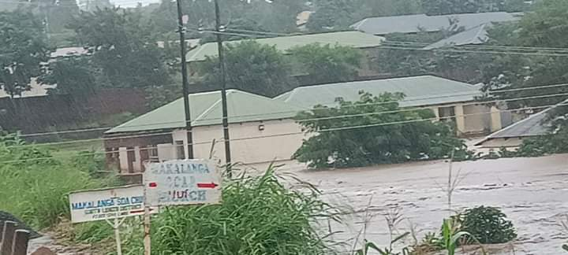
Some of the effects of the rainfall. Left: part of Machinjiri road in Blantyre swept by the running water. Right: houses sub-merged due to heavy rains.

We got scared upon hearing the news that Chisombedzi river overflooded. This is close to some of our institutions in Maryview – Nguludi. At the onset of this year’s growing season, heavy rains blew off the roof of one classroom block at Montfort Demonstration Primary School. It costs millions for the Brothers to re-roof the classroom block. Hearing of the damages been caused by the downpour of this month, our fears arose.
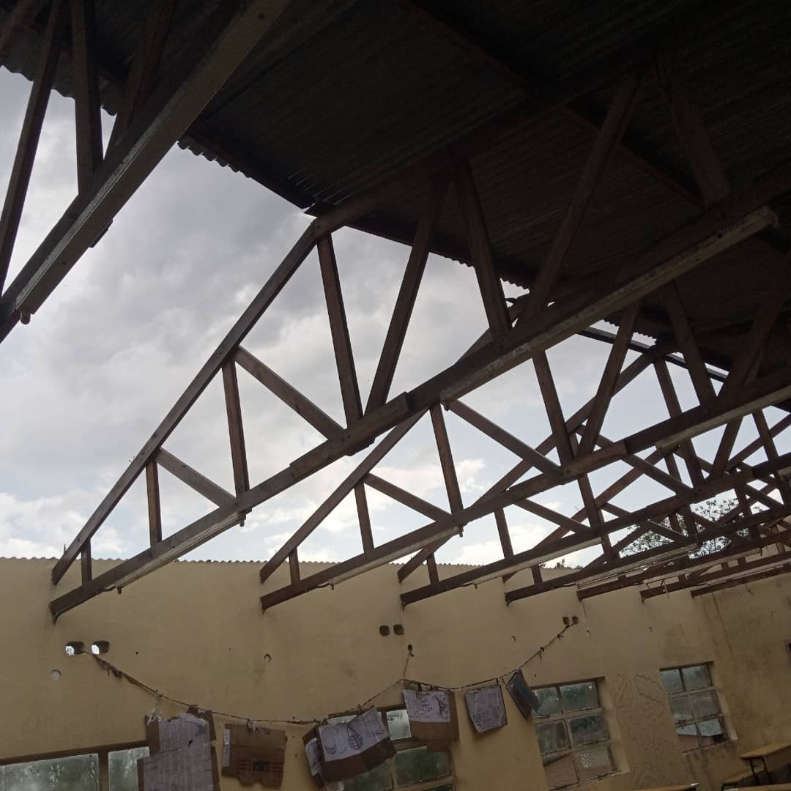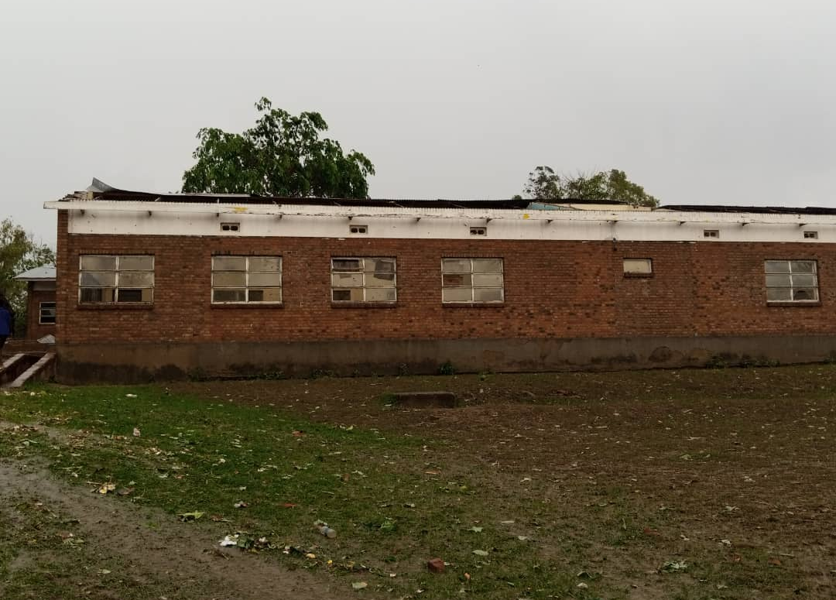
A classroom block of Montfort Demonstration Primary School which got damaged previously with heavy rains.

As the rains continue, we are worried that it may cause further damage to property and plants. We have not yet received any news of damage to property in our communities. The roads to Mzedi, where we have a community of Brothers FIC and two secondary schools (St. Patrick’s and St. Louis Community Day), is impassable for it has developed gullies. We hope to be still protected from this down pour.

Compiled by Bro. Gasper Kalisto
On behalf on Provincial Council of Brothers FIC-Malawi

